Font and Bitmap File Converter
Font and Bitmap File Converter

The utility allows converting bitmap (BMP extension), raster (FNT extension) or true type font (TTF extention) files into formats to be used with Microchip Graphics Library. Raster font file can be extracted from MS Windows bitmap font package file (FON extension) or converted from true type font file (TTF extension) with a third party font editor.

The font is a copyrighted material so please ensure that you have rights to use it. You may find free fonts distributed under Open Font License (OFL) agreement. Some of the fonts distributed under OFL may be found here http://scripts.sil.org/cms/scripts/page.php?site_id=nrsi&item_id=OFL_fonts.

You may also buy fonts at reasonable prices from many clipart websites.

If you want to edit fonts like image for better result then you need to use font editor. You may also create new fonts with font editor. One such freeware editor Fony is available at http://hukka.furtopia.org. Another example is http://fontforge.sourceforge.net.

Add following text “Please use external picture editor to convert JPEG or other format images to bitmap. You can use standard editor like Microsoft Paint to do this. For advanced image editing get software like GIMP (www.gimp.org). It supports capability to do generate optimized color palette for image which can reduce image size.

The main window of the conv.exe utility has a list box to display items chosen for conversion and several control buttons.

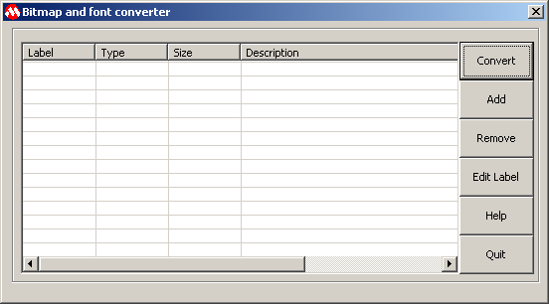

Adding bitmap to conversion list
Adding bitmap to conversion list

To add a bitmap for conversion following steps should be done:

- Press “Add” button. Open file dialog will appear.
- In the dialog select “Bitmap Files (*.bmp)” filter. Browse for the bitmap file to be converted and press “Open” button.
- If selected file will be imported successfully the information about it (label, type, size and description) will be added in the list box of the main window. Label is generated from the file name, type defines that imported object is a bitmap, size of data is shown in bytes, and description contains basic information. Generated label must be used for the reference to this bitmap in the application.
- To change label double click on it. The first label letter cannot be a number.

Adding raster font to conversion list
Adding raster font to conversion list

To add a raster font for conversion following steps should be done:

- Press “Add” button. “Open file” dialog will appear.
- In the dialog select “Raster Font (*.fnt)” filter. Browse for the font file to be converted and press “Open” button.
- “Set Characters Range” dialog will appear.

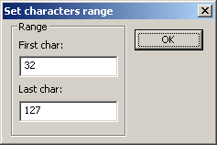

- Enter a range (first and last characters) to be loaded from the font file and press “OK”. If operation will be successful the information about font (label, type, size and description) will be added in the list box of the main window. Label is generated from file name, type defines that imported object is a font, size of data is shown in bytes, and description contains basic information. Generated label must be used for the reference to this font in the application.
- To change label double click on it. The first label letter cannot be a number.

Adding true type font to conversion list
Adding true type font to conversion list

To add a true type font for conversion following steps should be done:

- Press “Add” button. “Open file” dialog will appear.
- In the dialog select “True Type Font (*.ttf, *.otf)” filter. Browse for the font file to be converted and press “Open” button.
- “Set Font Style” dialog will appear.

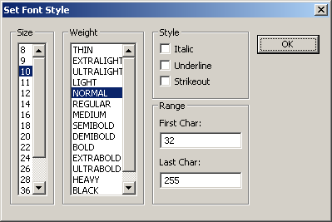

- Enter size, weight, style, characters range and press “OK”. If the operation will be successful the information about font (label, type, size and description) will be added in the list box of the main window. Label is generated from file name, type defines that imported object is a font, size of data is shown in bytes, and description contains basic information. Generated label must be used for the reference to this font in the application.
- To change label double click on it. The first label letter cannot be a number.

Removing item from conversion list
Removing item from conversion list

To remove some item from conversion list select this item and press “Remove” button.

Conversion
Conversion

The utility allows converting data into several formats:
- Intel Hex File (32 bit linear format)
- C File containing data array to be located in internal flash memory

Conversion into Intel Hex File
Conversion into Intel Hex File

This output format should be selected to store bitmaps and fonts in external memory. Address of each object will be aligned by 4 bytes border. In addition to Intel hex file the utility will generate C file containing structures FONT_EXTERNAL and BITMAP_EXTERNAL. These structures must be used in application to access converted pictures and fonts in external memory. Name of the reference C file will be the same as name of the hex file with “ref.c” appended.

To create Intel Hex and reference C files following steps must be performed:

- Press “Convert” button.
- “Save File” dialog will appear.
- Select “Intel Hex File (*.hex)” filter.
- Browse or enter file name.
- Press “Save” button.
- “Data offset and memory ID” dialog will appear.

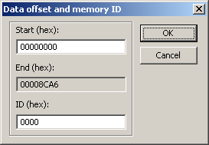

- Enter start address if the converting data must have special location in the external memory.
- Enter memory ID. Memory ID is a unique number assigned by application for the memory chip where data will be stored. This number allows distinguishing memory chip if the application has several of them.
- Press “OK”.

Conversion into C file containing array to be located in internal flash memory
Conversion into C file containing array to be located in internal flash memory

This conversion type should be used to store fonts and bitmaps into internal flash memory. The following steps must be performed:

- Press “Convert” button.
- “Save File” dialog will appear.
- Select “Array In Internal Flash (*.c)” filter.
- Browse or enter file name without extension.
- Press “Save” button.

Conversion into Binary File
Conversion into Binary File

This output format allows creating binary files for objects in the conversion list. Each bitmap or font image will be stored in a separate file. The following steps should be done:

- Press “Convert” button.
- “Save File” dialog will appear.
- Select “Binary (*.bin)” filter.
- Browse or enter file name without extension. The result files names will be created as concatenation of the entered file name, object’s label and “.bin” extension.
- Press “Save” button.

Microchip Graphics Library Bitmap Image Format
Microchip Graphics Library Bitmap Image Format

Image Structure for Bitmap

Block | Name | Bits | Description
Header | Reserved | 8 | Reserved
Header | Bpp | 8 | Bits per pixel in the bitmap
Header | Height | 16 | Image height in pixels
Header | Width | 16 | Image width in pixels
Color Table | First color value | 16
Color Table | … | … | …
Color Table | Last color value | 16
Raster Data | … | … | …

Color table entry format

Bits | 15 | 14 | 13 | 12 | 11 | 10 | 09 | 08 | 07 | 06 | 05 | 04 | 03 | 02 | 01 | 00
Value | R | R | R | R | R | G | G | G | G | G | G | B | B | B | B | B

Raster Data encoding

Pixels are stored left-to-right, up-to-bottom. Color indices are zero based, meaning a pixel color of 0 represents the first color table entry, a pixel color of 255 (if there are that many) represents the 256th entry. For images with more than 256 colors there is no color table.

Raster Data encoding for 1bit / black & white images
Every byte holds 8 pixels, its highest order bit representing the leftmost pixel. There are 2 color table entries.

Raster Data encoding for 4bit / 16 color images
Every byte holds 2 pixels, the least significant 4 bits represents the leftmost pixel. There are 16 color table entries.

Raster Data encoding for 8bit / 256 color images
Every byte holds 1 pixel. There are 256 color table entries.

Raster Data encoding for 16bit / hicolor images
Every 2bytes / 16bit holds 1 pixel. The pixels are no color table pointers. There are no color table entries. Color coded in format:

Bits | 15 | 14 | 13 | 12 | 11 | 10 | 09 | 08 | 07 | 06 | 05 | 04 | 03 | 02 | 01 | 00
Value | R | R | R | R | R | G | G | G | G | G | G | B | B | B | B | B

Microchip Graphics Library Font Image Format
Microchip Graphics Library Font Image Format

Font Image Structure

Block | Char | Name | Bits | Description
Font Header |  | Rsv | 8 | Reserved for future use (must be set to 0)
 |  | Font ID | 8 | User-assigned ID number
 |  | FirstChar | 16 | Character code of first character in font (e.g. 32)
 |  | LastChar | 16 | Character code of last character in font (e.g. 3006)
 |  | Rsv | 8 | Reserved for future use (must be set to 0)
 |  | Height | 8 | Character height in pixels
Character Table | 1st char | Offset MSB | 8 | Offset from font table start (8 MSBs)
Character Table | 1st char | Width | 8 | Width in pixels
Character Table | 1st char | Offset LSB | 16 | Offset from font table start (16 LSBs)
Character Table | 2nd char | Offset MSB | 8 | Offset from font table start (8 MSBs)
Character Table | 2nd char | Width | 8 | Width in pixels
Character Table | 2nd char | Offset LSB | 16 | Offset from font table start (16 LSBs)
Character Table | … | … | … | …
Character Table | … | … | … | …
Character Table | … | … | … | …
Character Table | Last char | Offset MSB | 8 | Offset from font table start (8 MSBs)
Character Table | Last char | Width | 8 | Width in pixels
Character Table | Last char | Offset LSB | 16 | Offset from font table start (16 LSBs)
Font Bitmap | 1st char |  | Char width dependent | Bitmap data of character
Font Bitmap | 2nd char |  | Char width dependent | Bitmap data of character
Font Bitmap | ... |  | ... | ...
Font Bitmap | Last char |  | Char width dependent | Bitmap data of character

Font header
All characters have the same height. FirstChar and LastChar define the first and last characters in the font image.

Character table
This table is an array of entries each consisting of two 2-byte WORDs. The second byte of each entry is the character width. The first BYTE and second WORD of each entry is the byte 24 bits offset from the beginning of the image to the character bitmap. The number of entries in the table is calculated as ((LastChar - FirstChar) + 1.

Font bitmap
This field contains the character bitmap definitions. Each character is stored as a contiguous set of bytes. Each bit represents one pixel. Pixels are stored left-to-right, up-to-bottom.

